Please complete the following automation exercises using your automation test tool of choice.

Please structure your solution as you would do in a work environment / setting.

**UI Automation**

On ebay.com website, please automate the following test scenario

Scenario 1 – Verify item can be added to Cart

1. Open browser
2. Navigate to ebay.com
3. Search for ‘book’
4. Click on the first book in the list
5. In the item listing page, click on ‘Add to cart’
6. verify the cart has been updated and displays the number of items in the cart as shown below in yellow.

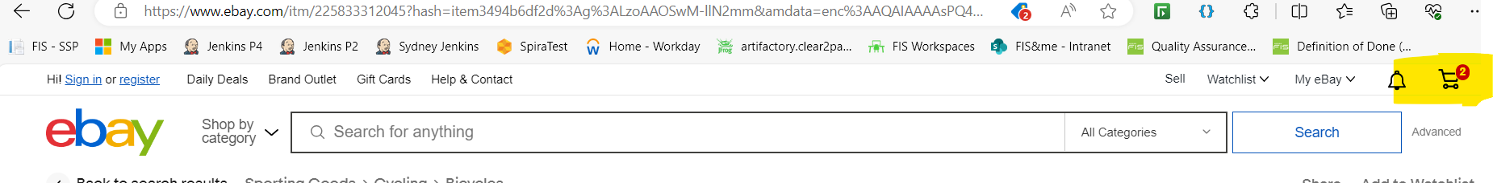

**Solution:**

**public class EbayTest {**

**public static void main(String[] args) {**

**System.setProperty("webdriver.chrome.driver", "path/to/chromedriver");**

**WebDriver driver = new ChromeDriver();**

**try {**

**driver.get("https://www.ebay.com");**

**WebElement searchBox = driver.findElement(By.id("gh-ac"));**

**searchBox.sendKeys("book");**

**searchBox.submit();**

**WebElement firstBook = driver.findElement(By.xpath("//*[@id=’item1b10032fec’]”));**

**firstBook.click();**

**WebElement addToCartButton = driver.findElement(By.id("atcRedesignId_btn"));**

**addToCartButton.click();**

**WebElement cartIcon = driver.findElement(By.id("gh-cart-n"));**

**String cartCount = cartIcon.getText();**

**System.out.println("Items in cart: " + cartCount);**

**if (!cartCount.equals("1")) {**

**System.out.println("Cart update failed!");**

**} else {**

**System.out.println("Cart updated successfully.");**

**}**

**} catch (Exception e) {**

**e.printStackTrace();**

**} finally {**

**driver.quit();**

**}**

**}**

**}**

**API Automation**

On the following endpoint - [api.coindesk.com/v1/bpi/currentprice.json](https://api.coindesk.com/v1/bpi/currentprice.json), automate the following

1. Send the GET request
2. Verify the response contains
   1. There are 3 BPIs
      1. USD
      2. GBP
      3. EUR
   2. The GBP ‘description’ equals ‘British Pound Sterling’.

**Solution:**

**public class ApiTest {**

**@Test**

**public void testBpiResponse() {**

**RestAssured.baseURI = "https://api.coindesk.com/v1/bpi";**

**Response response = given()**

**.when()**

**.get("/currentprice.json")**

**.then()**

**.statusCode(200)**

**.extract().response();**

**response.then().body("bpi", hasKey("USD"));**

**response.then().body("bpi", hasKey("GBP"));**

**response.then().body("bpi", hasKey("EUR"));**

**response.then().body("bpi.GBP.description", equalTo("British Pound Sterling"));**

**}**

**}**